Set gpu for code

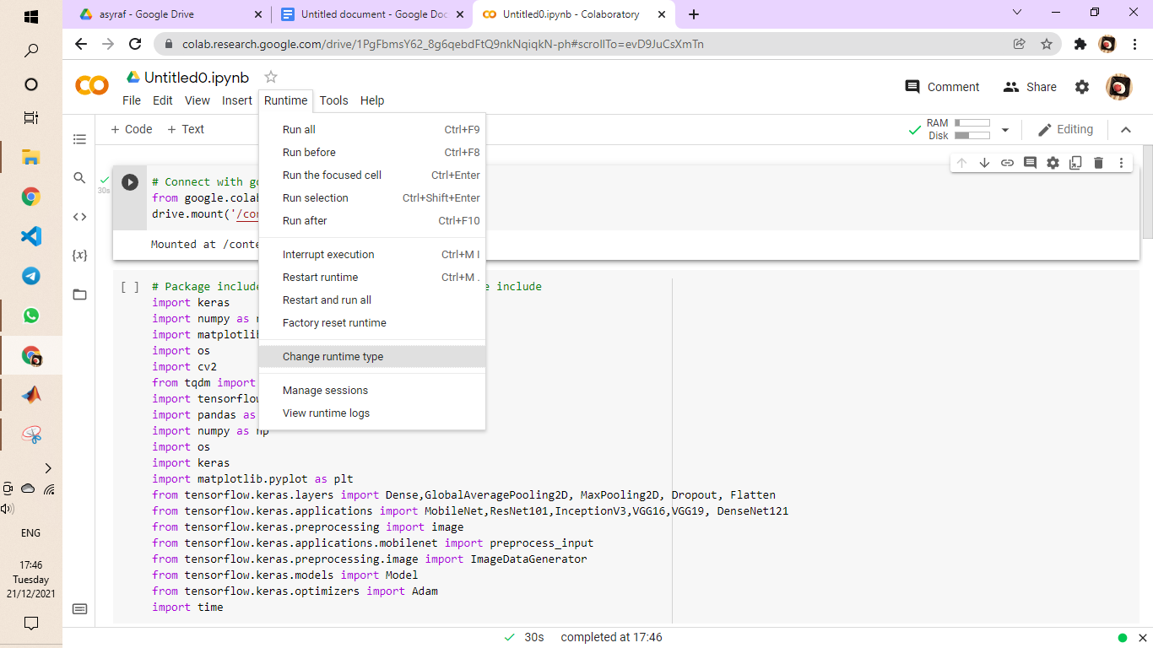

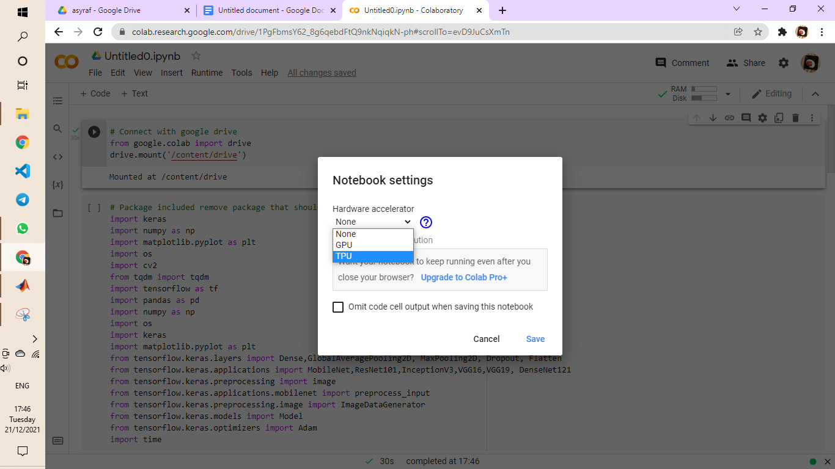

* Run Time >> Change run time type >> GPU@CPU >> save
* Pilih nk GPU @ TPU

Set path to drive

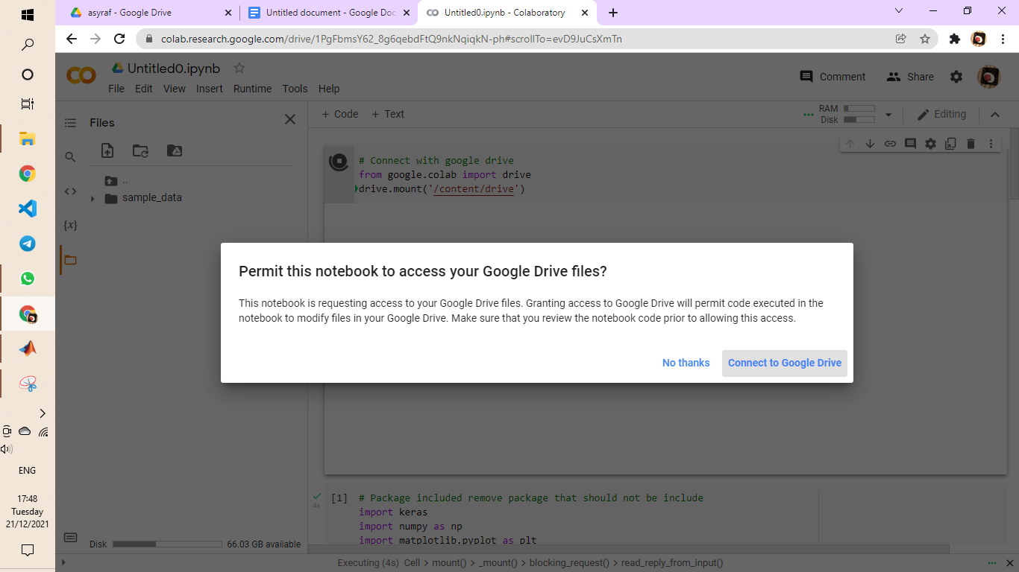

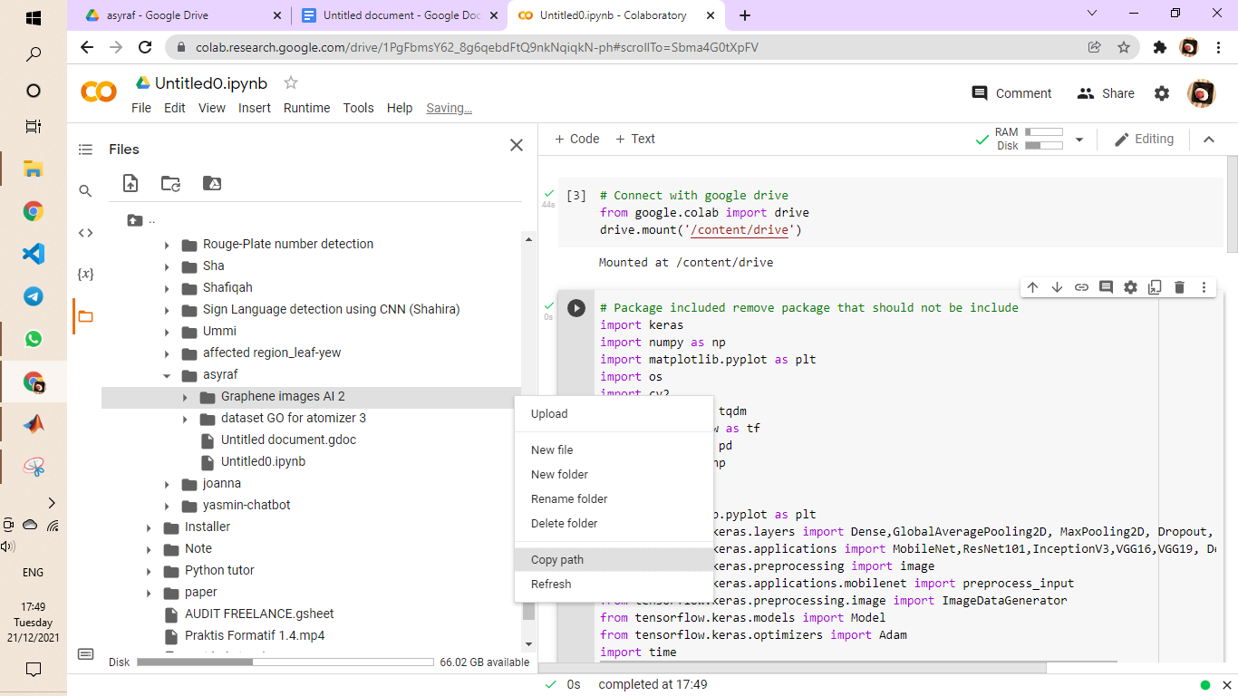

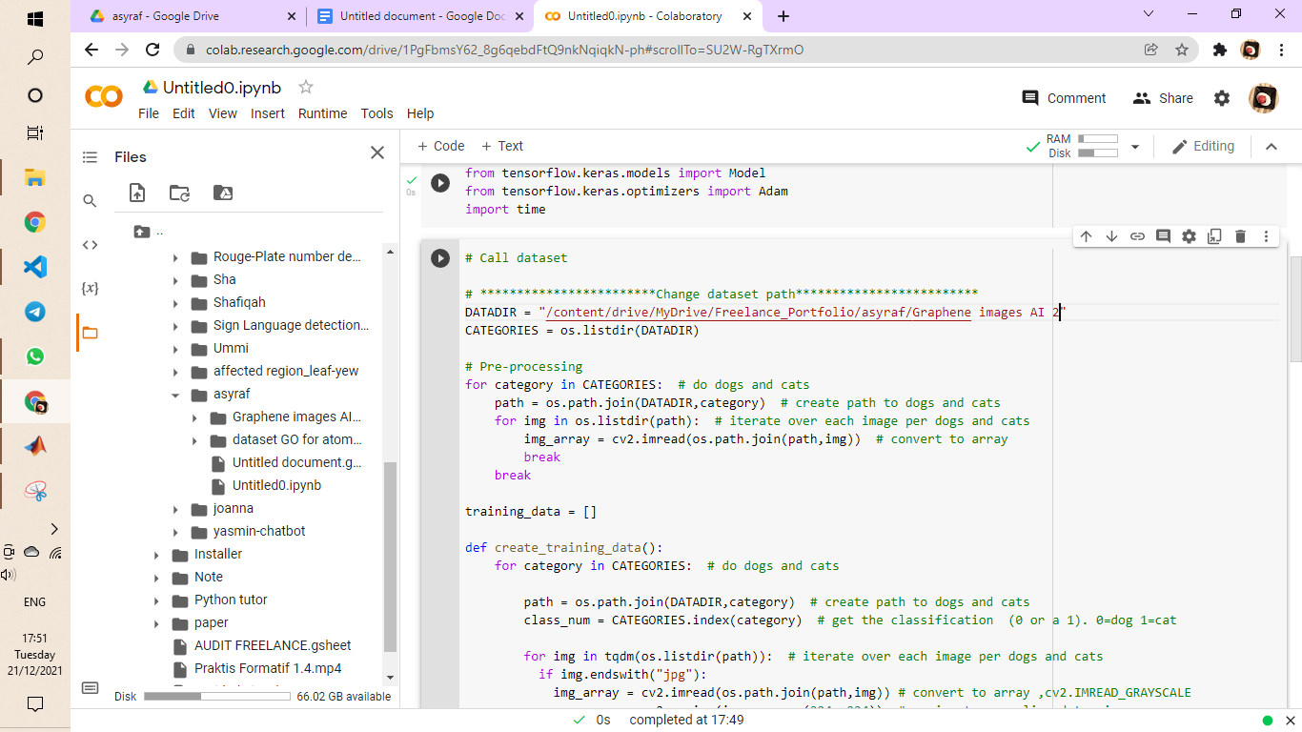

* Connect dgn google drive (run macam biasa)
* Enter folder pilih folder dataset copy path set dekat DATADIR

CNN model

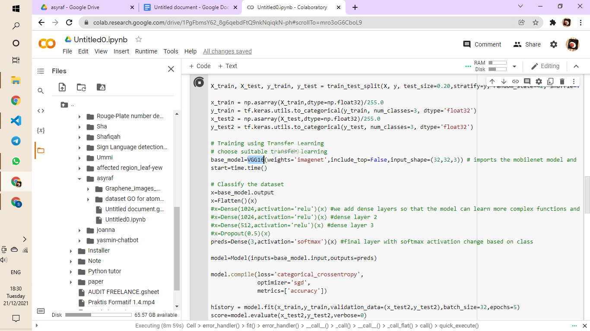

* Pilih model VGG16, VGG19, mobilenet, Resnet ubah dekat highlight tu